Volume management in AWS

1.create a new instance
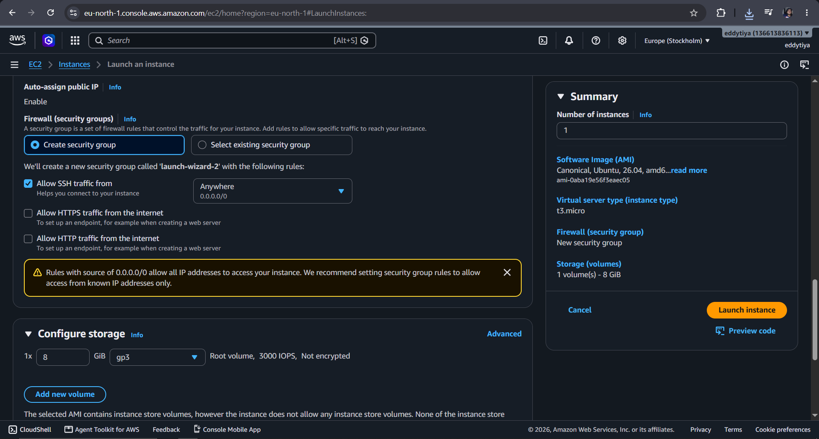

--the roor volume here is 8 gb cannot be less than 8 gb

2.lsblk and df -h
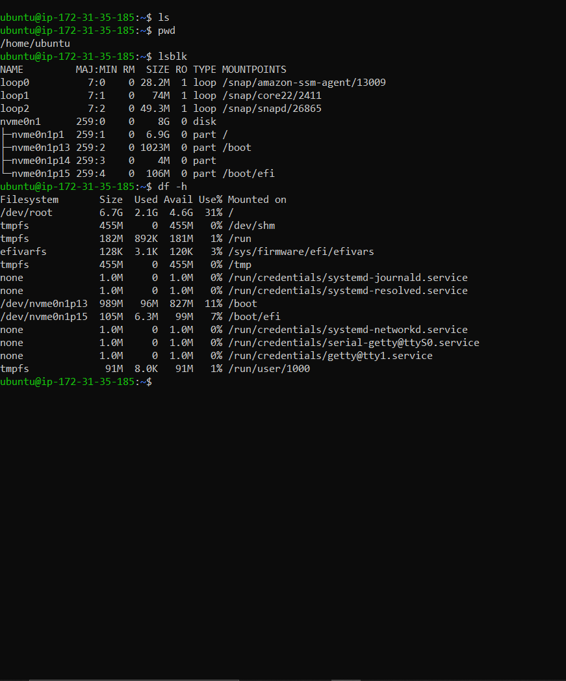

Mounting is when you attach a volume to a specific memory location

Now open ebs
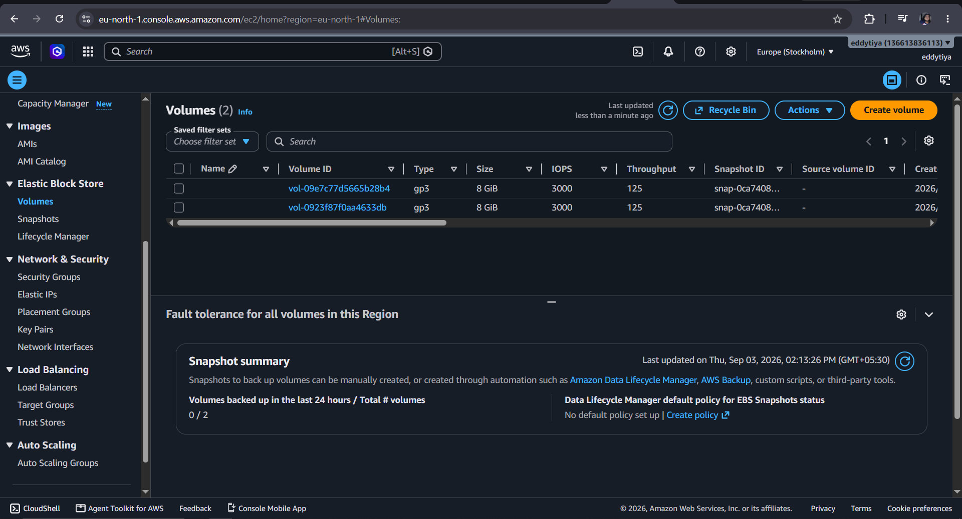

Create volume

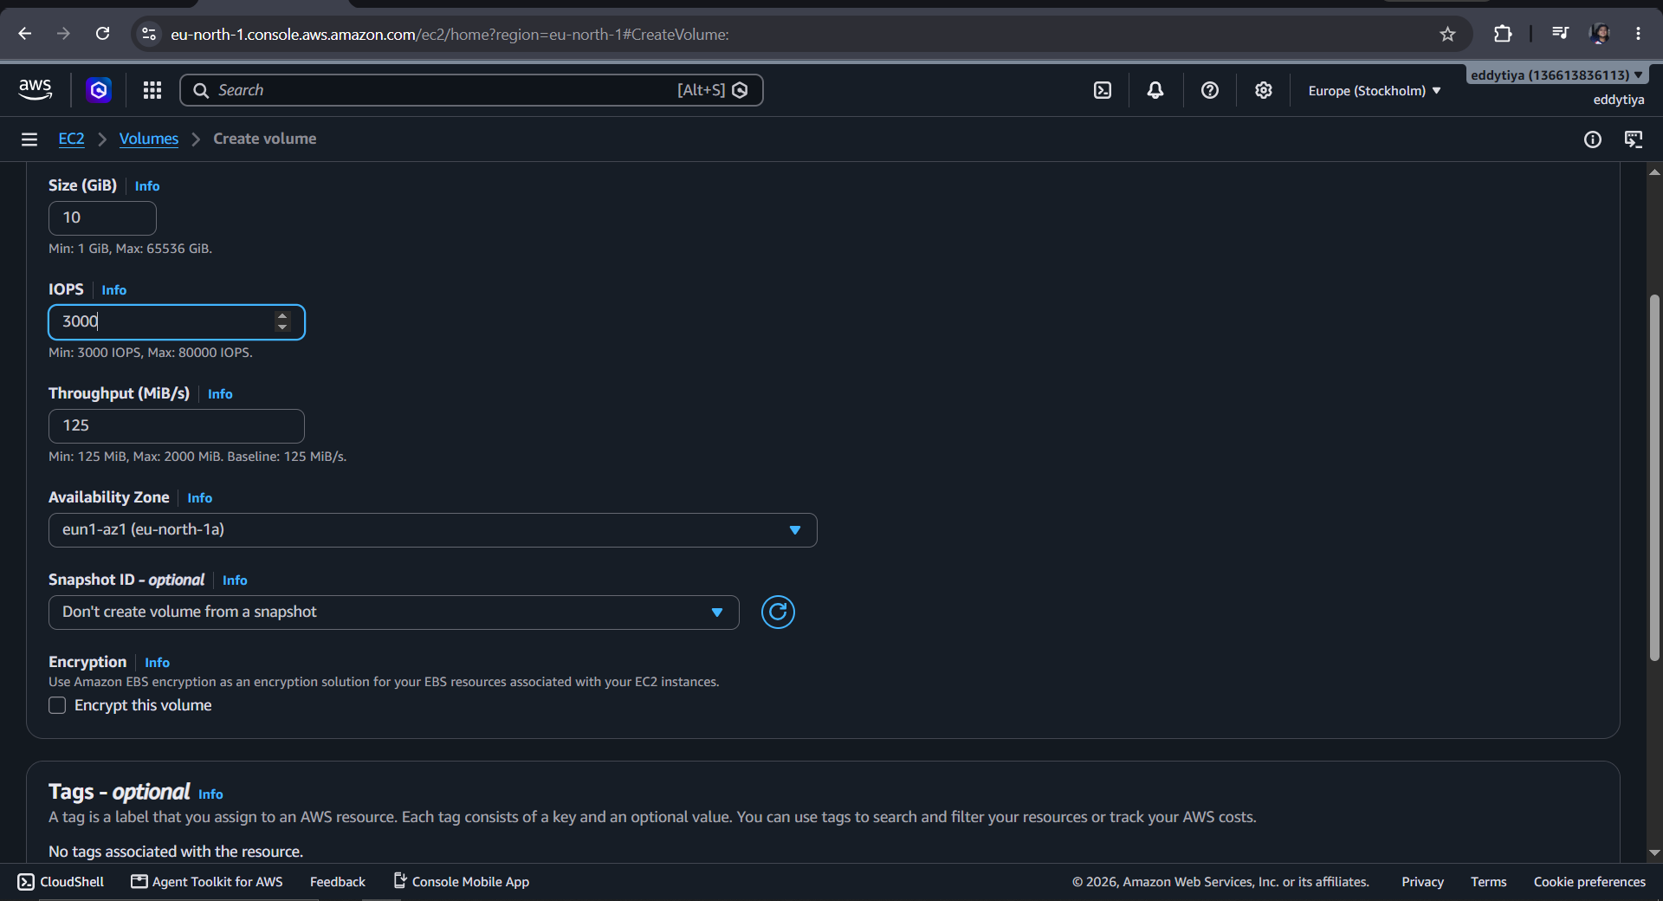

Attach it
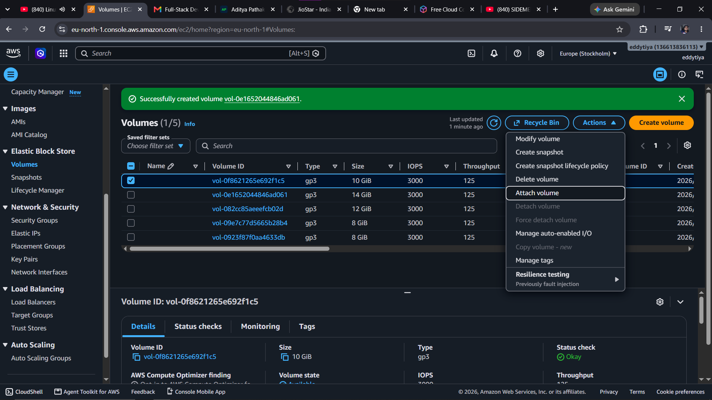

We need toselect device name and should start from [f] cause before that is already attached
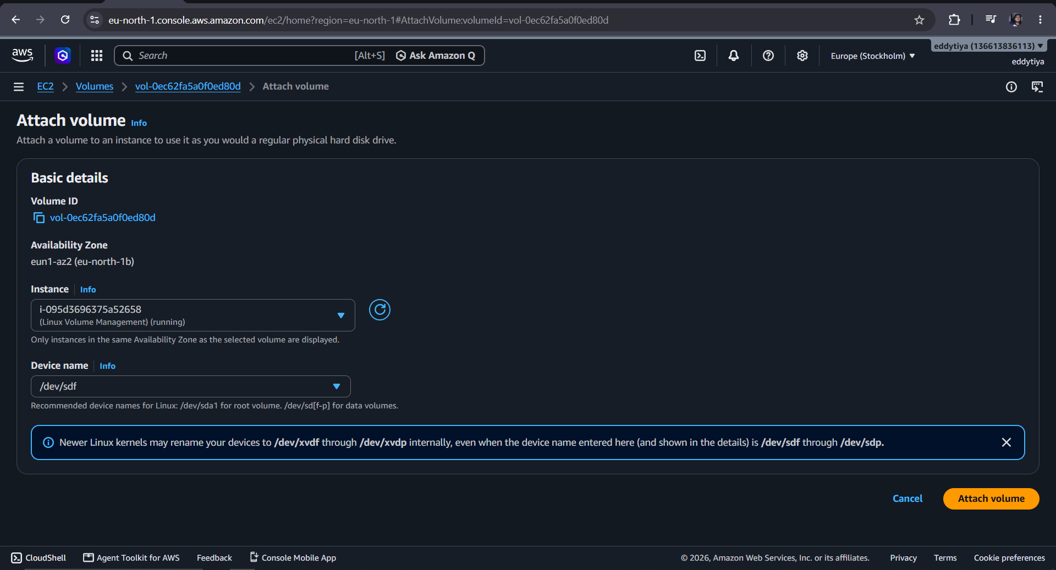

Attach 3 volumes 10,12,14

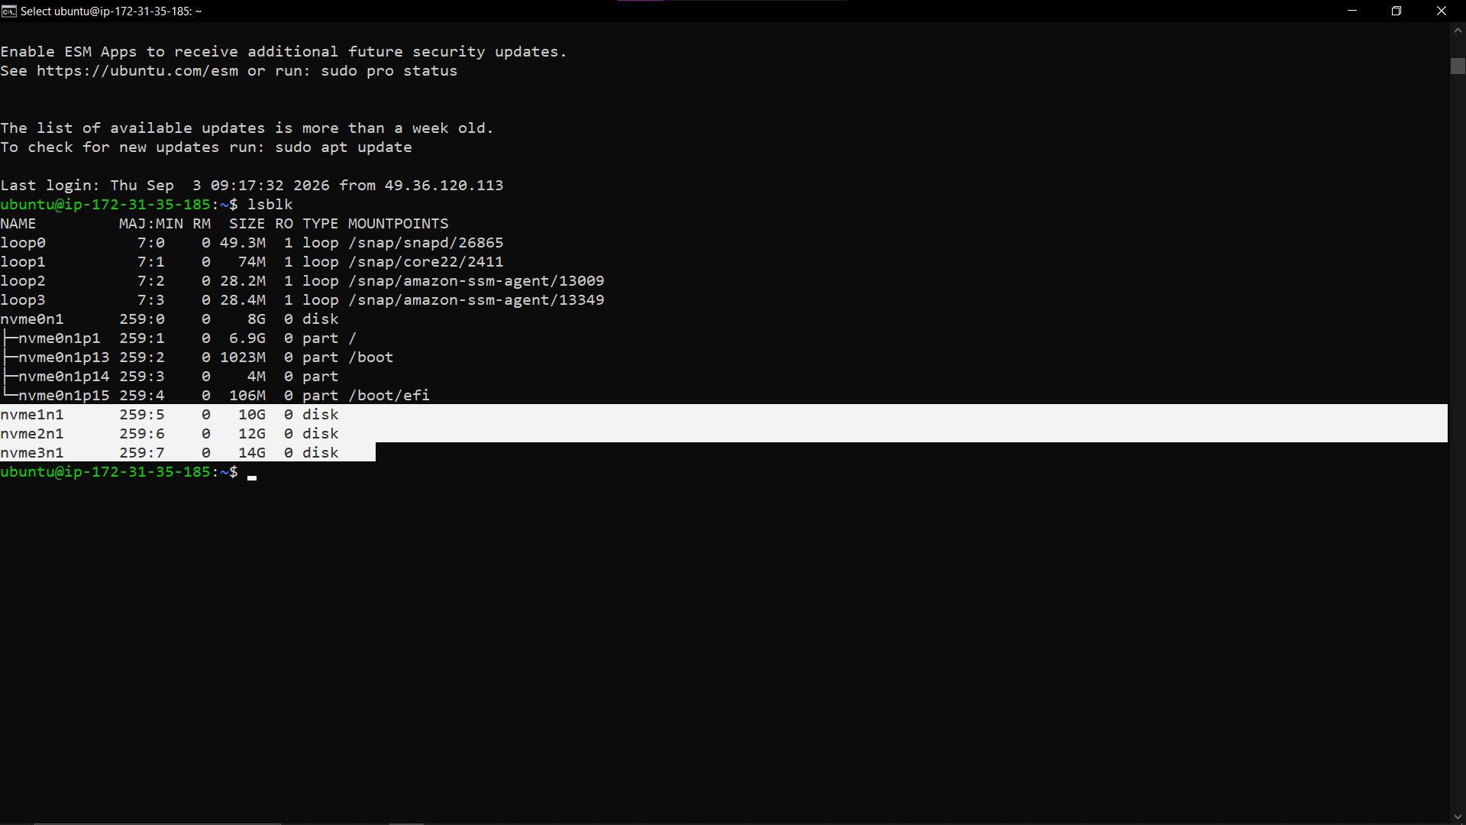

Attached but mount point is still empty

Lvm
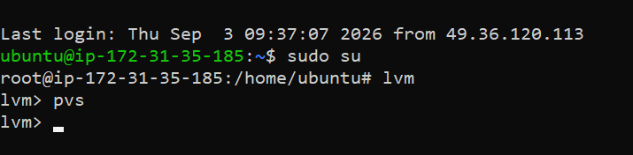
Pvs to see what physical volumes we have

Creating physical volumes
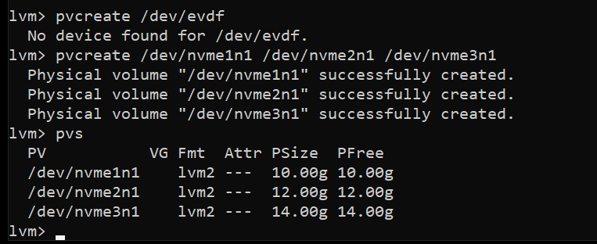

Creating a volume group
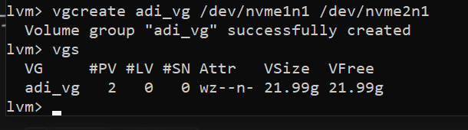

Creating a logical volume
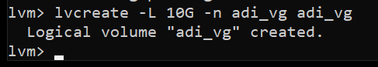

Another example of volume
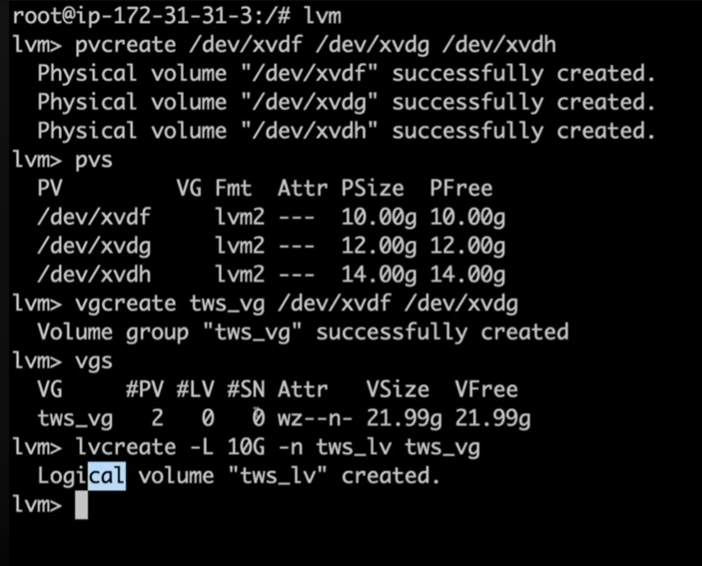

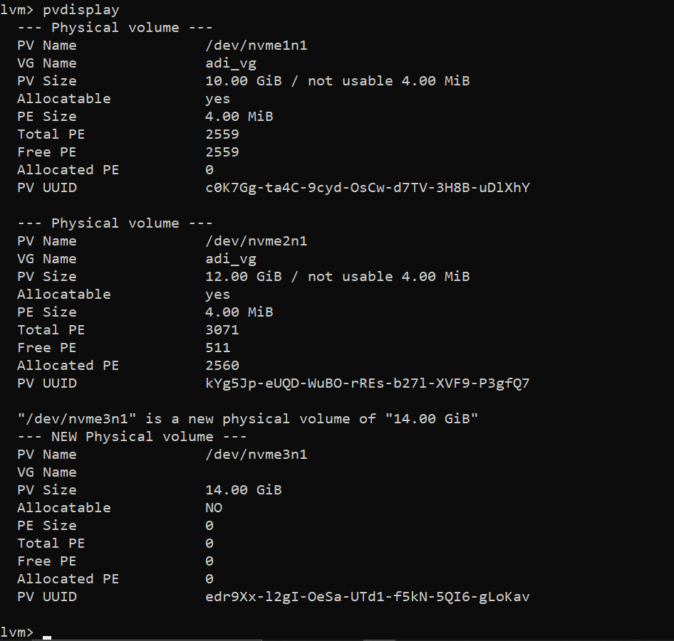
\\\

Now mounting

Now create a new di to place a mount location
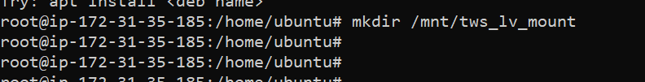

Now we need to format the volume
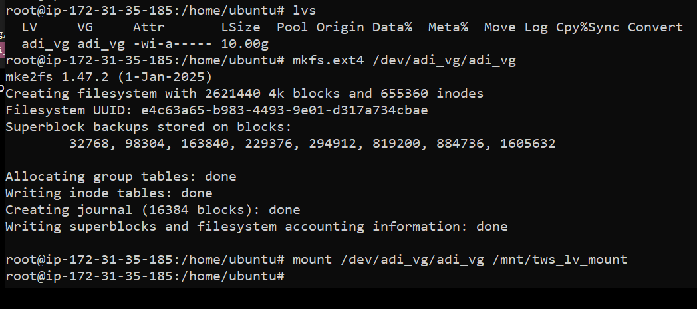

mounted
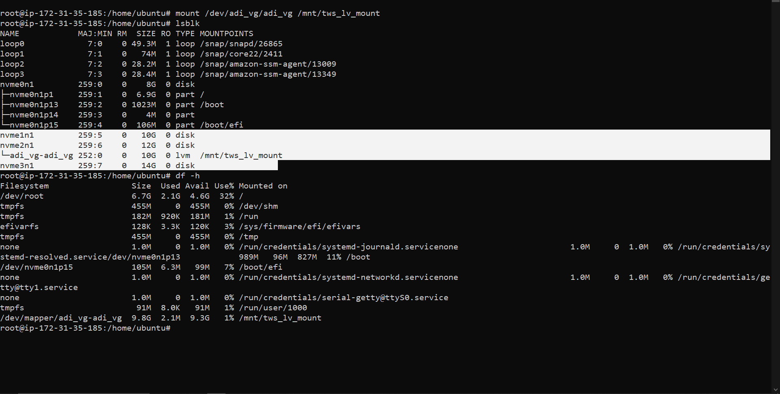

Now for the remaining disk
